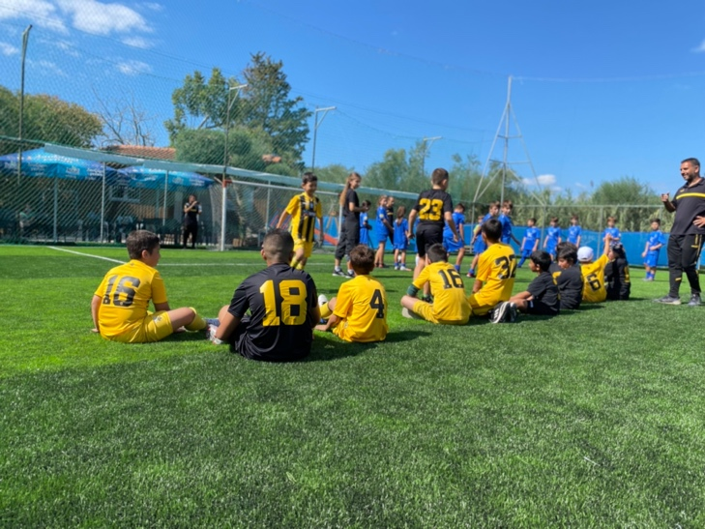
The AEK FC was established by Greek Refugees from Constantinopolis in 1924. Thus, it seems like it is their destiny to continue the migrant and refugee tradition within their team. Athens Comics Library has been working with the AEK FC on the European program Welcome Through Football. Besides AEK FC, Welcome Through Football cooperates with other famous European clubs like Benfica Lisbon or Everton FC.
The project itself is holistically structured. Even though many could think that the program focuses mainly on football and football skills improvement, there is more – the program also pays the same attention to children's socialization. Integration in a new country is very challenging for both children and adults. Thus, the project enables the children to make friends, and parents can also meet each other and become closer.
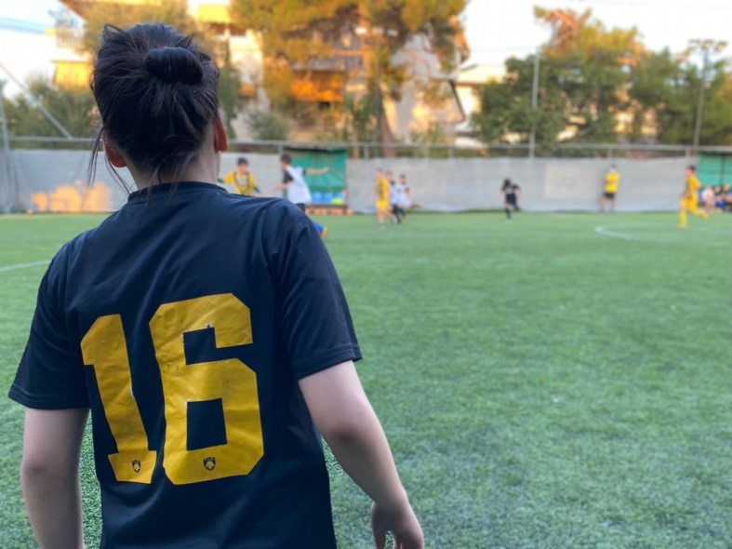
Another thing that is worth mentioning is that the program is not only for boys but also for girls, and the team has the same approach to all children. The project also meets three of the Sustainable Development Goals: good health and well-being, quality education, and reduced inequalities.
As I am a student of the International Studies at the Mendel University Brno, and I have chosen to focus on the topic of refugee and migrant children and their integration, I was happy to accept to complete my work placement within Athens Comics Library. I was a bit pessimistic a first, as I know that sometimes organizations that are founded for helping others are often failing to fulfil their purpose. However, since the first minute, I have realized that this project is unique among the others.
I had a chance to ask each child and their parents/carers about their opinion on the project. All of them are enjoying every session and are always looking for the next one. Finally, I would love to sum up my feelings in few words: It's amazing to finally be a part of something that works! There is nothing more than seeing the children happy, and as we know, children are the future of the world, so let's take care of them!

